European Union

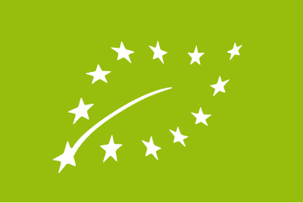

Organic farmers, processors and traders, must comply with strict EU requirements if they want to use the EU organic logo or label their products as organic.
EU legislation ensures that 'organic' means the same for consumers and producers all over the EU. Legislation concerning organic produce is developed with the participation of Member States and the assistance of advisory and technical committees and expert bodies.
In 2007 the European Council of Agricultural Ministers agreed on a new Council Regulation (Council Regulation(EC) No. 834/2007) setting out the principles, aims and overarching rules of organic production and defining how organic products were to be labelled.
The regulation set a new course for developing organic farming further, with the following aims:
- sustainable cultivation systems
- a variety of high-quality products
- greater emphasis on environmental protection
- more attention to biodiversity
- higher standards of animal protection
- consumer confidence
- protecting consumer interests.
Organic production respects natural systems and cycles. Biological and mechanical production processes and land-related production should be used to achieve sustainability, without having recourse to genetically modified organisms (GMOs).
In organic farming, closed cycles using internal resources and inputs are preferred to open cycles based on external resources. If the latter are used, they should be
- organic materials from other organic farms
- natural substances
- materials obtained naturally, or
- mineral fertilisers with low solubility.
Exceptionally, however, synthetic resources and inputs may be permissible if there are no suitable alternatives. Such products, which must be scrutinised by the Commission and EU countries before authorisation, are listed in the annexes to the implementing regulation (Commission Regulation (EC) No. 889/2008).

